

UNIVERSITY OF PETROLEUM AND ENERGY STUDIES

SUB-DATA COMMUNICATION AND NETWORKS
LAB FILE
TOPIC-INTERCONNECTING DEVICES



SUBMITTED BY- SUBMITTED TO-
MEHIR SAXENA MR.RAJIB BANERJEE
500123380 BATCH-01
DCN Lab Report
Topic: Implementation of Star and Ring Topology using 15 Devices

1. Introduction
Network topology defines the layout of the network and how devices (nodes) are connected and communicate with each other. Among several topologies, Star and Ring are foundational in both theoretical and practical networking.
This experiment aims to simulate and understand the functioning of Star and Ring topology using 15 end devices (PCs) and network switches in Cisco Packet Tracer.

2. Objectives
- To implement Star topology using 15 PCs.
- To implement Ring topology using 15 PCs.
- To simulate both topologies in Cisco Packet Tracer.

3. Tools Used
- Cisco Packet Tracer (Version 7.x or above)
- End Devices: PC-PT (15 nodes)
- Network Devices: Cisco 2960-24TT Switch
- Cables: Copper Straight-through
- Connectivity Type: Static / Simple simulation (ping tests)

4. Implementation of Star Topology
Steps:
- Open Cisco Packet Tracer.
- Place 3 switches in the workspace (Switch0, Switch1, and Switch3).
- Connect 5 PCs to each switch using Copper Straight-through cables.
- Interconnect all 3 switches using a central switch (Switch4) forming a star backbone (central point).
- Assign IP addresses to each PC (optional for ping testing).
- Use the simulation tab to test communication between PCs across all switches.
Topology Highlights:
- Total PCs: 15 (5 per switch × 3)
- Total Switches: 4 (including backbone)
- Centralized connectivity ensures robust fault isolation.
- Efficient for real-time communication.
- 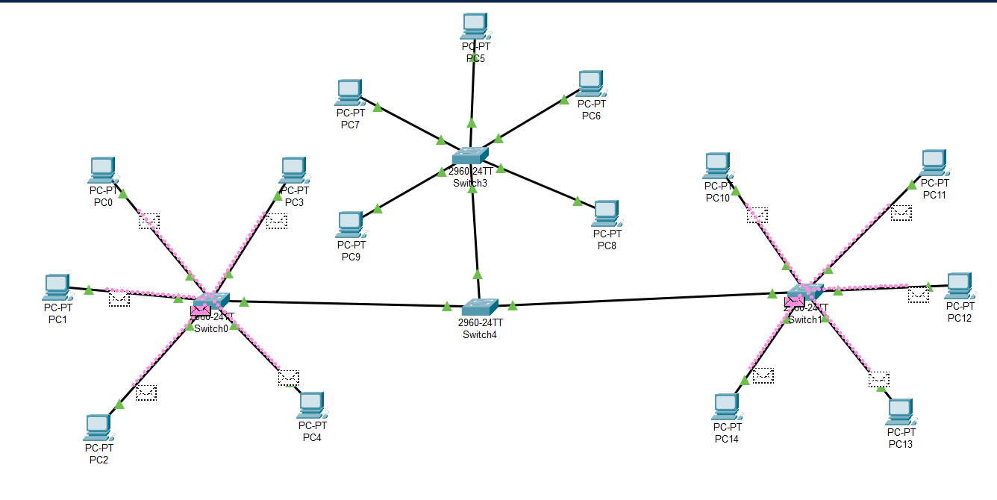

5.Implementation of Ring Topology
Steps:
- Place 4 switches in the workspace (Switch0 to Switch3).
- Connect each switch to 3–5 PCs using Copper Straight-through cables.
- Create a ring by connecting switches sequentially:
  - Switch0 → Switch1 → Switch2 → Switch3 → back to Switch0
- This forms a loop for ring topology.
- Assign IP addresses and verify communication using the ping tool.
- Ensure all switches are linked to complete the ring.
Topology Highlights:
- Each switch serves as a node in the ring.
- Data flows in a loop; performance depends on proper link functioning.
- Simulates a fault-sensitive but cabling-efficient network.
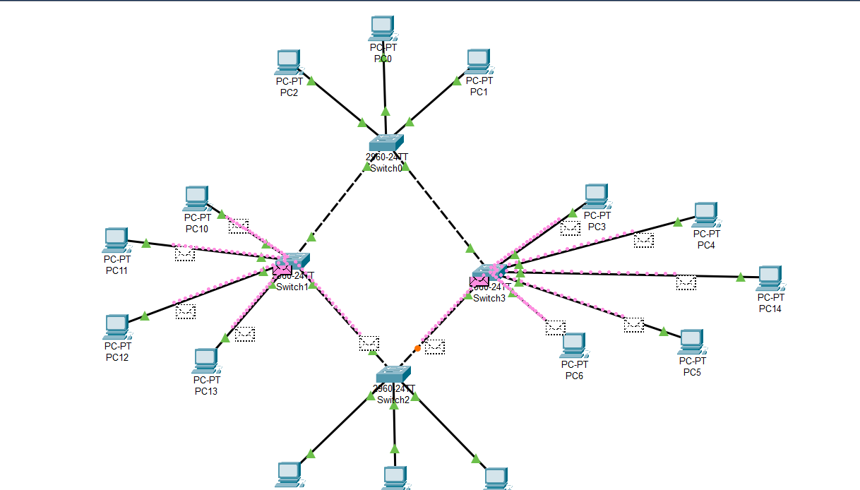

Conclusion
In conclusion, the practical demonstrated the clear differences between star and ring topologies in terms of performance, scalability, and fault tolerance. Star topology emerged as the more robust and practical solution for modern network setups, particularly in environments requiring high availability and manageability. However, ring topology still holds relevance in specific use cases where simplicity and predictable data paths are prioritized.

